E2E Health Check Accelerator - Comprehensive Technical Documentation.
1. Overview
This document outlines the design, architecture, and user guide for the Costscence Accelerator, a comprehensive Snowflake Enterprise Analytics Platform built using Streamlit. The application provides enterprise-grade cost monitoring, storage management, warehouse optimization, security analytics, and advanced performance tracking capabilities across Snowflake accounts.
Purpose: To streamline Snowflake cost management and operational visibility through an intuitive web interface, enabling database administrators, data engineers, and finance teams to monitor consumption, optimize resource utilization, and manage costs effectively across the enterprise.
Intended Results: Enhanced operational efficiency through data-driven optimization, better resource allocation decisions, identification of inefficient queries and unused warehouses, and standardized cost management practices across the organization.
2. Objectives
Monitoring: Real-time tracking of credit consumption, cost trends, and spending patterns across all Snowflake resources
Warehouse Optimization: Comprehensive warehouse performance analysis including efficiency metrics, credit consumption, and configuration recommendations
Storage Management: Advanced storage tracking for permanent tables, transient tables, failsafe data, materialized views, and stage storage
Security & Compliance: Role-based access control, user activity monitoring, privilege management, and audit trail capabilities
Performance Analytics: Query analysis, long-running query identification, task performance monitoring, and UDF/stored procedure execution tracking
Advanced Analytics: Population Stability Index (PSI), data quality metrics, anomaly detection, and performance benchmarking
Operational Efficiency: Reduce manual reporting through automated dashboards and intelligent analytics
Decision Support: Provide actionable insights for infrastructure planning and cost optimization
3. Requirements
Core Administration Features
Account Overview: High-level snapshot of account usage, credit consumption, and key metrics
Warehouse Analytics: Detailed warehouse performance, cost breakdown, and efficiency analysis
Storage Metrics: Comprehensive storage tracking by type, trend analysis, and database-level attribution
Role & User Analytics: User activity tracking, role assignment analysis, and privilege management
Performance Monitoring: Query analysis, long-running query detection, and bottleneck identification
Cost Management: Credit consumption tracking, cost forecasting, and budget monitoring
Login Activity Tracking: Security monitoring through login history and failed login analysis
Date Range Filtering: Flexible date selection for custom period analysis (Last 7 days, Month, Quarter, Custom)
Advanced Features
Query Spillage Analysis: Identification of queries spilling to remote storage with performance impact assessment
Task Performance Monitoring: Failed task analysis with cost implications
UDF/Stored Procedure Execution: Function execution tracking and performance metrics
Idle Resource Detection: Identification of unused roles, inactive databases, and underutilized warehouses
Trend Analysis: 90-day rolling window analysis for historical comparison and anomaly detection
Data Quality Metrics: Null ratios, distinct ratios, outlier detection, and domain validation
Multi-Warehouse Comparison: Side-by-side warehouse efficiency and cost analysis
Export Capabilities: Data export for further analysis in external tools
Non-Functional Requirements
Performance:
Response Time: Page loads under 3 seconds for typical operations
Concurrent Users: Support 100+ simultaneous users
Data Caching: Smart caching with TTL for expensive Snowflake queries (metadata: 90s, usage data: 300-1800s)
Progressive Loading: Incremental data loading for large inventories
Query Optimization: Aggregation at database level to minimize data transfer
Scalability:
Multi-Account Support: Ability to manage multiple Snowflake accounts
Horizontal Scaling: Stateless design supporting load balancing
Resource Efficiency: Optimized Snowflake connection pooling
Data Volume Handling: Efficient processing of large historical datasets
Usability:
Responsive Design: Mobile-friendly interface for monitoring and quick decisions
Intuitive Navigation: Tab-based navigation with contextual filters and actions
Error Handling: Clear error messages with troubleshooting suggestions
Search & Filter: Comprehensive filtering across dates, warehouses, users, and roles
Real-time Updates: Dynamic metrics with refresh controls
Maintainability:
Modular Architecture: Clear separation between UI components, business logic, and data layers
Configuration Management: Externalized settings and environment-specific configurations
Logging & Monitoring: Comprehensive application logging and audit trails
Code Documentation: Inline comments and function documentation for maintainability
4. System Architecture
The Costsense Accelerator follows a three-tier architecture with clear separation between presentation, business logic, and data persistence layers.
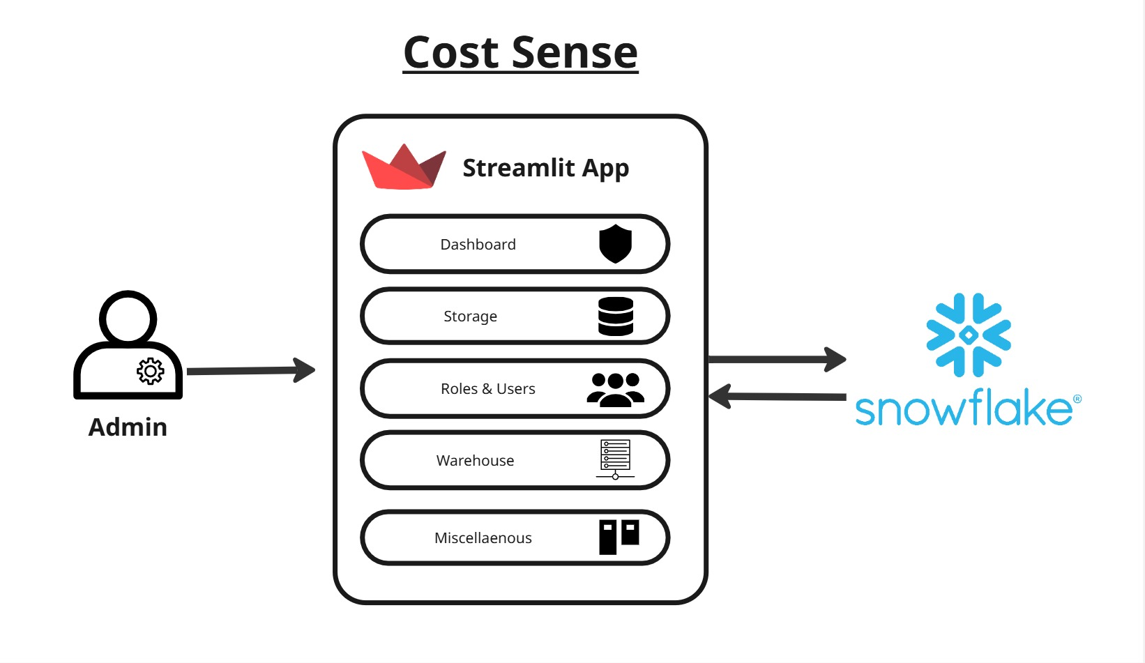
Architecture Components
Presentation Layer (Streamlit Frontend):
- Web Interface: Streamlit-based responsive single-page application with sidebar navigation
- Session Management: Stateful user sessions with date range context persistence
- Multi-level Caching: Client-side caching for UI responsiveness
- Authentication: Snowflake native authentication with connection management
- Dynamic Rendering: Conditional rendering based on data availability and user selections
Business Logic Layer (Python Application):
- Query Builder: Dynamic SQL construction based on selected filters and date ranges
- Data Processors: Specialized functions for metrics calculation and aggregation
- Chart Generator: Plotly integration for interactive visualization generation
- Styling Engine: Corporate CSS application and theme management
- Session Manager: Environment context and state management
- Cache Manager: TTL-based caching with selective invalidation
Data Layer (Snowflake):
- ACCOUNT_USAGE Schema: Historical metrics (Query History, Warehouse Metering, Storage Usage, Login History, Task History)
- INFORMATION_SCHEMA: Real-time metadata and object information
- System Metadata Views: USERS, ROLES, GRANTS_TO_USERS tables
- Materialized Views: Pre-aggregated data for performance-critical queries
Key Design Patterns
- Repository Pattern: Abstracted Snowflake data access with centralized query management
- Builder Pattern: Dynamic SQL query construction based on filters and parameters
- Observer Pattern: Real-time UI updates for metric cards and chart data
- Factory Pattern: Dynamic chart creation based on data type and visualization requirements
- Decorator Pattern: Function-level caching with TTL configuration
- Strategy Pattern: Multiple aggregation strategies for different metric types.
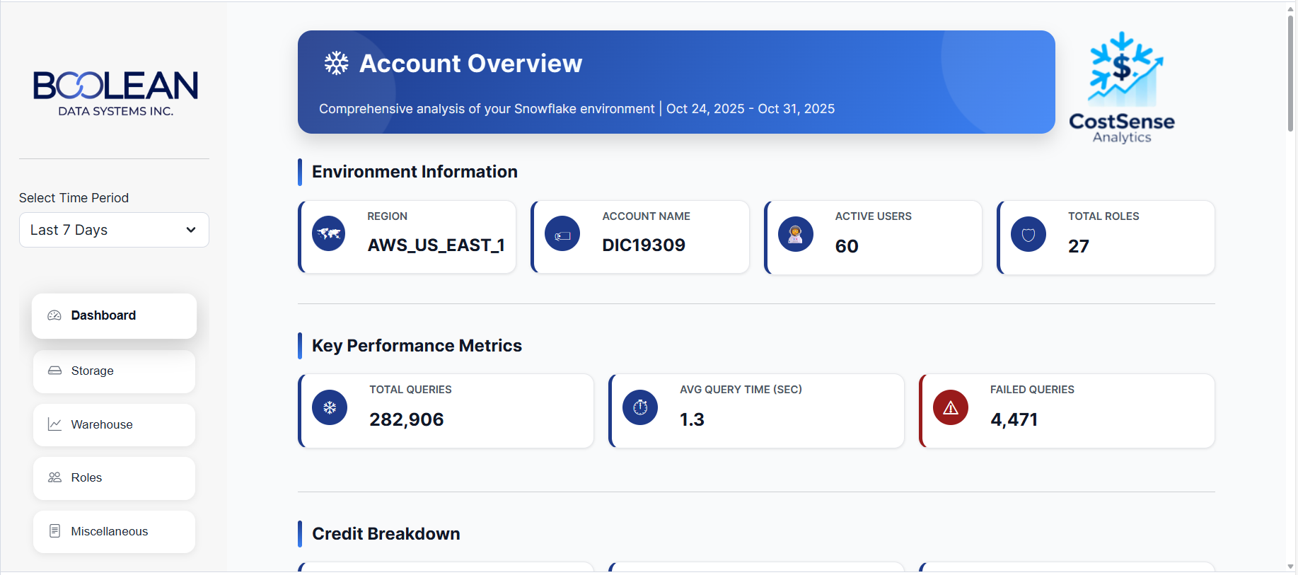
5. User Interface (UI) / User Experience (UX)
Design Philosophy
The interface follows enterprise analytics design principles with emphasis on clarity, data-driven decision-making, and visual hierarchy. The design uses a professional blue color scheme (#1e3a8a primary) with high contrast elements for accessibility and IBM Plex Sans typography for corporate consistency.
Key UI Components
Navigation Structure:
- Sidebar Navigation: Environment context with date range filter
- Tab-based Content: Logical grouping of related analytics (Dashboard, Warehouse, Storage, Roles, Miscellaneous)
- Metric Cards: Real-time KPI display with refresh controls
- Interactive Charts: Plotly-based visualizations with hover details
- Responsive Grid Layout: Dynamic column adjustment for different screen sizes
Dashboard Overview:
- Header Section: Corporate branding with subtitle and timestamp
- KPI Tiles: Real-time metrics with optional change indicators
- Chart Library: Multiple visualization types (bar, area, pie, scatter)
- Quick Filters: Environment and date range selectors
- Data Tables: Sortable, filterable data displays with pagination
Styling Guide:
Colors:
- Primary Brand: #1e3a8a (Deep Blue)
- Primary Light: #3b82f6 (Lighter Blue)
- Success: #065f46 (Dark Green)
- Warning: #c2410c (Amber)
- Danger: #991b1b (Deep Red)
- Gray 600: #4b5563 (Medium Gray)
- Gray 700: #374151 (Dark Gray)
- Gray 800: #1f2937 (Very Dark Gray)
- Background: #f7f8fa (Light Gray)
- Panel: #ffffff (White)
Typography:
- Headers: IBM Plex Sans, Bold (700)
- Body Text: IBM Plex Sans, Regular (400)
- Code/SQL: Monospace font with syntax highlighting
- Font Sizes: H1 (1.75rem), H2 (1.5rem), Body (1rem), Small (0.875rem)
Spacing & Layout:
- Grid System: 12-column responsive layout
- Container Padding: 1rem standard
- Component Margins: 0.5rem standard, 1rem for sections
- Border Radius: 1rem for cards, 10px for inputs
- Box Shadows: Subtle (0 10px 20px rgba(0,0,0,0.15)) for depth
Responsive Design
- Desktop (>1024px): Full grid layouts with side-by-side charts
- Tablet (768px - 1024px): 2-column to 1-column transitions
- Mobile (<768px): Single column, adjusted font sizes, stacked components
6. Application Layout and User Guide
The Costsense Accelerator is a user-friendly web interface designed to simplify Snowflake cost management and operational analytics. It allows users to:
- Monitor account-wide cost consumption and credit usage patterns
- Analyze warehouse performance and efficiency metrics
- Track storage utilization across databases and stages
- Manage user roles and analyze access patterns
- Identify performance bottlenecks and optimization opportunities
- Forecast costs and plan resource allocation
Main Components
- Header: Displays corporate branding, current page title, and environment context
- Sidebar: Date range filter and navigation menu with icon indicators
- Main Workspace: Tab-based content display with dynamic filtering
- Chart Area: Interactive Plotly visualizations with hover details
- Data Tables: Sortable tables with filtering and search capabilities
- Action Buttons: Clearly labeled refresh buttons for manual cache invalidation
Note: All data is sourced from Snowflake ACCOUNT_USAGE views and INFORMATION_SCHEMA in read-only mode. No data modifications are performed by this application.
Menu Structure
Menu | Purpose | Key Features
Dashboard | Account overview with key metrics and trends | KPI cards, credit breakdown, top charts
Warehouse | Warehouse performance and cost analysis | Configuration details, timeline analysis, efficiency metrics
Storage | Storage consumption and management | Storage types breakdown, trend analysis, database attribution
Roles & Users | Security and access control analytics | Role assignments, user activity, idle role detection
Miscellaneous | Advanced analytics and performance tuning | Query spillage, task failures, UDF execution, failed logins

7. Menu-by-Menu User Guide
7.1 Dashboard Overview
Purpose: Comprehensive account-level snapshot of Snowflake resource consumption and performance metrics.
KPI Section:
- Total Queries: Count of executed queries in selected date range
- Average Query Time: Mean execution time across all queries (seconds)
- Failed Queries: Count of failed query executions (indicator of issues)
- Compute Credits: Credits consumed by warehouse execution
- Cloud Service Credits: Credits for storage, networking, and services
- Total Credits Used: Sum of all credit consumption
Key Analytics:
- Database Storage Distribution
  - Horizontal bar chart showing storage usage by database
  - Percentage-based display for easy comparison
  - Dynamic bar heights based on data volume
- Daily Credit Consumption
  - Area chart showing credit trends over selected date range
  - Multi-warehouse stacking for comparative analysis
  - Hover details for exact daily values
- Query Count per User
  - Top 20 users by query count
  - Identifies most active users and usage patterns
  - Helpful for user-level cost attribution
- Daily Login Activity
  - User selector dropdown for individual analysis
  - Timeline of successful and failed login attempts
  - Security monitoring capability
- Database Usage Details
  - Table showing days since last query execution
  - Identifies unused and rarely-used databases
  - Supports cleanup and optimization decisions
- Warehouse Credits Consumption
  - Top 10 warehouses by credit usage
  - Shows credit distribution across infrastructure
  - Identifies optimization targets
- Long-running Queries Analysis
  - Queries exceeding 10-minute threshold
  - Execution time, user, warehouse, and database details
  - Prioritizes performance tuning efforts
Key Actions:
- Click refresh button on metric cards to update data
- Select date range using sidebar filter
- Hover over charts for detailed information
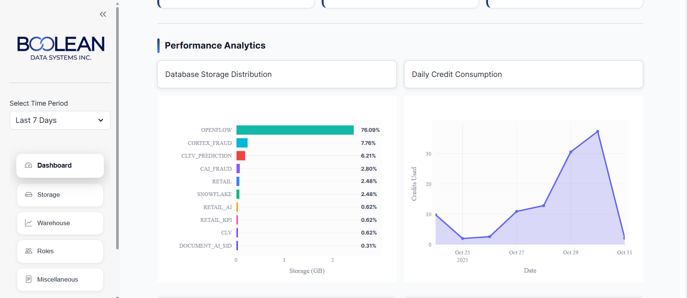

7.2 Warehouse Analytics
Purpose: Detailed warehouse performance monitoring, cost analysis, and configuration review.
Warehouse Overview Section:
- Total Warehouses: Count of virtual warehouses in account
- Total Credits: Cumulative credit consumption
- Compute Credits: Credits from warehouse execution
- Storage Credits: Credits from warehouse storage
Configuration Table:
- Displays all warehouses with key configuration parameters
- Auto-suspend Duration: Minutes before automatic suspension (color-coded: green ≤5 min optimal, orange 5-15 min, red >15 min suboptimal)
- Auto-resume Status: Whether warehouse automatically resumes
- Resource Monitor: Associated credit limits and alerts
- Health indicators based on configuration efficiency
Credit Timeline Analysis:
- Last 90 days of credit consumption history
- Bar chart with date-based breakdown
- Warehouse selector for focused analysis
- Shows seasonal patterns and consumption trends
Warehouse Deep Dive:
- Detailed analysis for selected warehouse
- Configuration review with best practice recommendations
- Performance metrics specific to warehouse
Performance Metrics:
- Warehouse Age Analysis
  - Ranking of warehouses by creation date
  - Identifies aging infrastructure
  - Supports lifecycle management
- Top Warehouse Credit Consumption
  - Top 10 warehouses ranked by total credits
  - Identifies primary cost drivers
  - Supports ROI analysis for each warehouse
- Query Activity per Warehouse
  - Count of queries executed per warehouse
  - Shows utilization patterns
  - Helps identify underutilized resources
- Average Query Duration
  - Performance characteristics of each warehouse
  - Query efficiency analysis
  - Identifies slow query patterns by warehouse
- Partner Tools Credit Consumption
  - Credits consumed by third-party integrations
  - Separate cost attribution for partner services
  - Budget tracking for vendor consumption
- Storage Consumption Trends
  - 90-day storage trend analysis
  - Warehouse-specific storage growth
  - Capacity planning insights
- Internal Stages Storage
  - Stage-specific storage metrics
  - Staging area optimization opportunities
  - Historical growth patterns
Key Actions:
- Select specific warehouse from dropdown for detailed analysis
- Use date range filter for custom period analysis
- Refresh metrics for latest data
Best Practices:
- Set auto-suspend to 5 minutes or less for cost optimization
- Monitor warehouses with >15% of total credit consumption
- Review failed query trends monthly
- Right-size warehouses based on query patterns
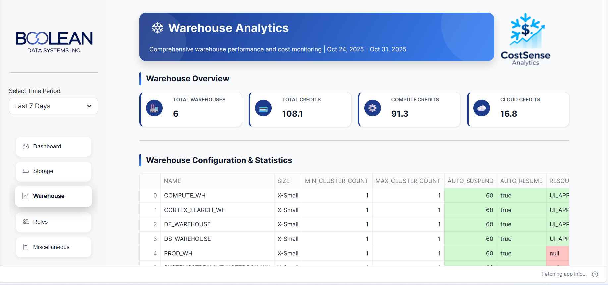
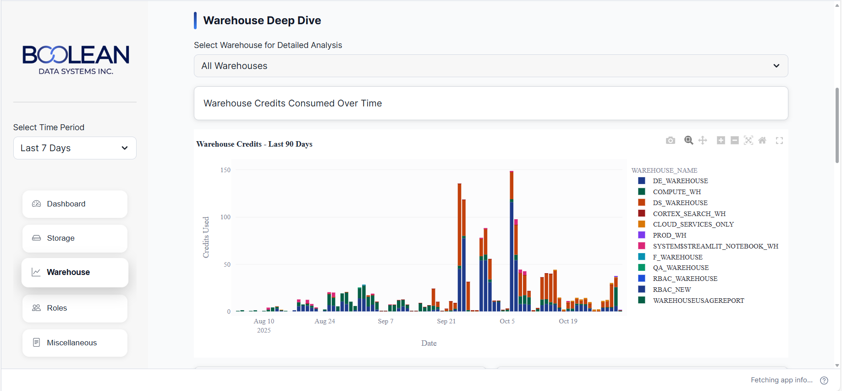

7.3 Storage Analytics
Purpose: Comprehensive storage tracking and management with trend analysis and cost attribution.
Storage Metrics Section:
- Permanent Tables Storage
  - Active bytes in permanent table format
  - Cumulative storage by database
  - Retained indefinitely after deletion
- Transient Tables Storage
  - Storage for temporary table format
  - No 7-day failsafe retention
  - Cost optimization through transient designation
- Failsafe Storage
  - 7-day disaster recovery data
  - Automatic retention (cannot be deleted)
  - Critical for compliance and recovery
- Materialized Views
  - Pre-computed query results storage
  - 30-day rolling average
  - Identified for optimization targets
- Stage Storage
  - External data staging areas
  - File-based storage metrics
  - Temporary staging optimization
Storage Analytics:
- Storage Consumption Over Time
  - Historical trend chart (90-day window)
  - Multi-type stacking visualization
  - Growth rate identification
- Database Storage Details
  - Storage by database with sorting
  - Days since last query execution
  - Identifies unused storage
- Internal Stages Analysis
  - Stage-level storage metrics
  - External connection details
  - Cleanup opportunities
- Storage Retention Review
  - Databases not accessed in 30+ days
  - Archival and cleanup candidates
  - Cost reduction opportunities
Key Actions:
- Analyze storage growth patterns for forecasting
- Identify databases not accessed in 60+ days for cleanup
- Review materialized view storage for optimization
- Monitor failsafe growth for cost planning
Optimization Recommendations:
- Transition rarely-accessed tables to transient format
- Archive aged data to external stages
- Remove unused materialized views
- Implement storage cleanup policies
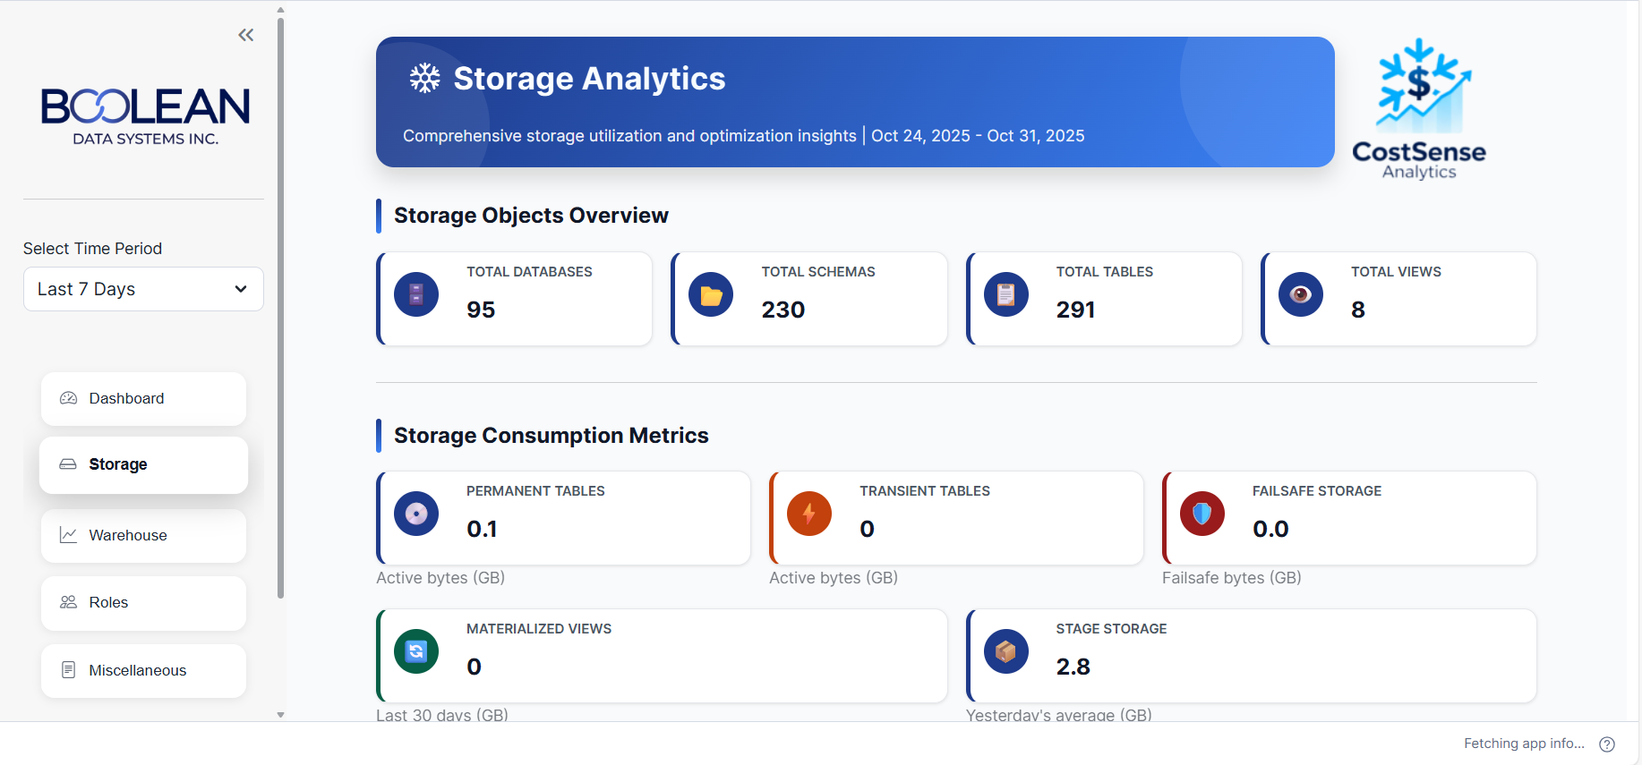
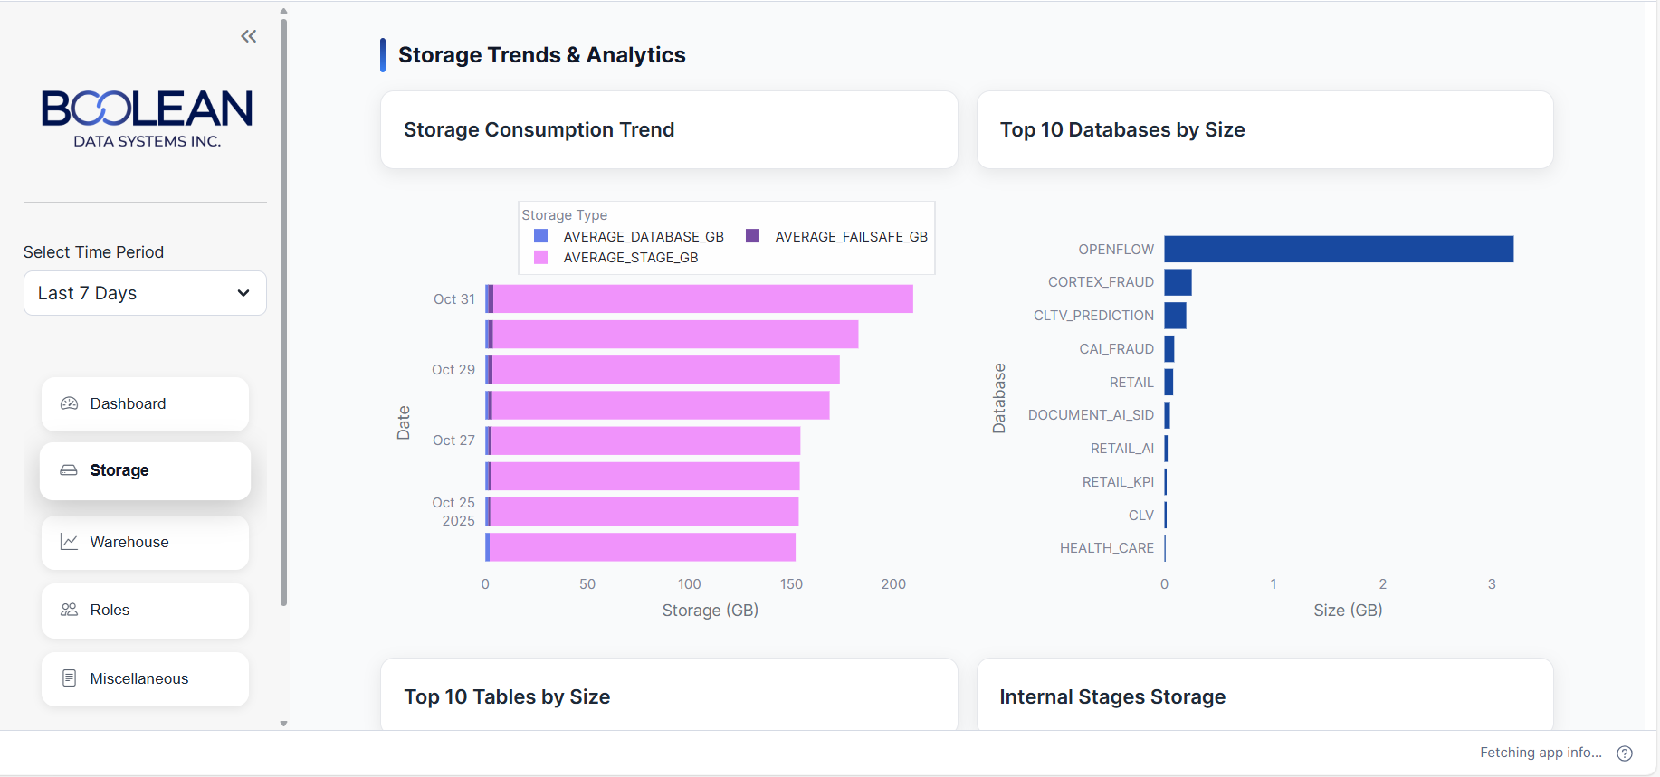

7.4 Roles & Users Analytics
Purpose: Security and access control management with activity tracking and optimization.
Role Analytics:
- Top Roles by User Assignment
  - Roles ranked by assigned user count
  - Privilege concentration analysis
  - Access control audit
- Idle Roles Analysis
  - Roles with 15+ days no query execution
  - Unused role identification
  - Cleanup candidates
- User Credit Consumption by Role
  - Role-based cost attribution
  - Spending patterns by organizational unit
  - Budget allocation analysis
- Role Assignment Summary
  - Table of all role-to-user mappings
  - Privilege levels and elevations
  - Comprehensive access inventory
- Elevated Privilege Role Analysis
  - Admin and power-user role tracking
  - Privilege escalation monitoring
  - Security audit trail
User Analytics:
- Top Users by Credit Consumption
  - Individual user cost attribution
  - Spending patterns
  - User-level optimization opportunities
- User Activity Timeline
  - Last query execution date for each user
  - Activity patterns and trends
  - Idle user identification
- User-to-Role Mapping
  - Comprehensive role assignment display
  - Multi-role assignments
  - Permission inheritance tracking
Key Actions:
- Review role assignments monthly for compliance
- Identify and remove unused roles
- Monitor elevated privilege assignments
- Track user activity for access certification
Security Best Practices:
- Follow principle of least privilege
- Rotate elevated privilege assignments
- Remove unused roles quarterly
- Document all privilege changes
- Regular access reviews (quarterly minimum)
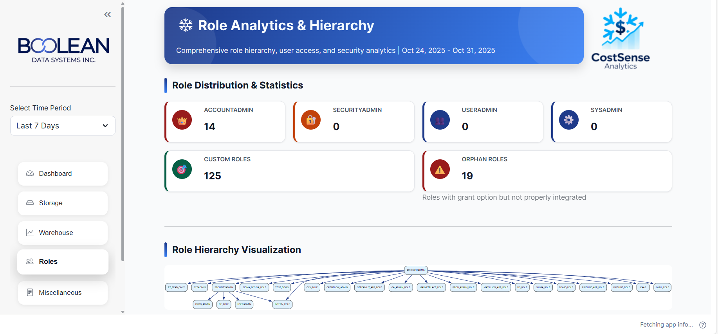
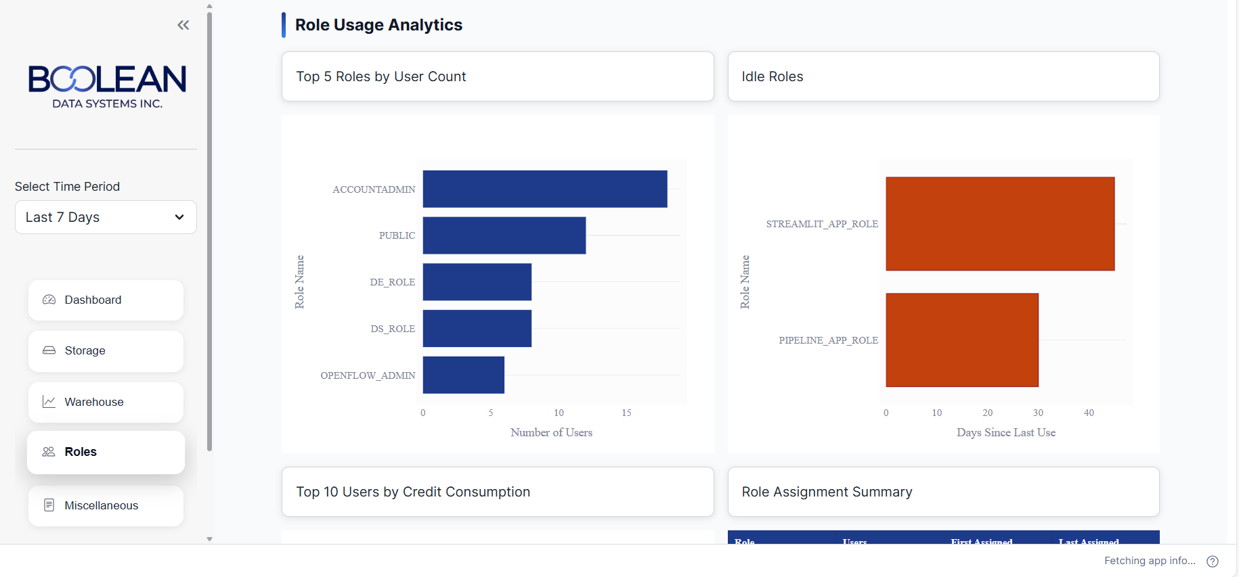

7.5 Miscellaneous - Advanced Analytics
Purpose: Performance optimization, security monitoring, and advanced operational analytics.
Query Performance Analytics:
- Top Inefficient Queries
  - Queries with remote storage spillage
  - Spillage amount in GB (query_max_data_scanned_for_result_remote_bytes)
  - Performance impact quantification
  - Query optimization priorities
- Query Metadata Details
  - User and warehouse attribution
  - Database and schema context
  - Execution timing and resource usage
  - Compilation vs execution time breakdown
Task Management:
- Failed Tasks Analysis
  - Tasks that failed execution
  - Failure frequency and patterns
  - Associated costs of failed runs
  - Root cause tracking
- Failed Task Details
  - Task scheduling and frequency
  - Warehouse assignments
  - Error message and diagnostics
  - Impact on dependencies
Function Execution Tracking:
- Executed Stored Procedures
  - Stored procedure execution count
  - User and database attribution
  - Performance characteristics
  - Resource utilization
- Executed UDFs (User Defined Functions)
  - UDF execution frequency
  - Language distribution (Python, SQL, Java)
  - Performance metrics
  - Resource consumption patterns
Security Monitoring:
- Failed Login Timeline
  - Failed login attempt history
  - Day-by-day failure counts
  - Trend identification
  - Security incident detection
- Failed Logins by Client Type
  - Breakdown by client application (Drivers, UI, etc.)
  - Client-specific failure patterns
  - Integration troubleshooting
  - Access control validation
Key Actions:
- Use inefficient query list for performance tuning priorities
- Investigate failed tasks for process reliability
- Monitor function execution for usage patterns
- Review failed logins for security incidents
Optimization Focus:
- Reduce query spillage through query optimization or warehouse upsizing
- Monitor task failure rates (target: <1%)
- Track expensive function executions
- Alert on unusual failed login patterns
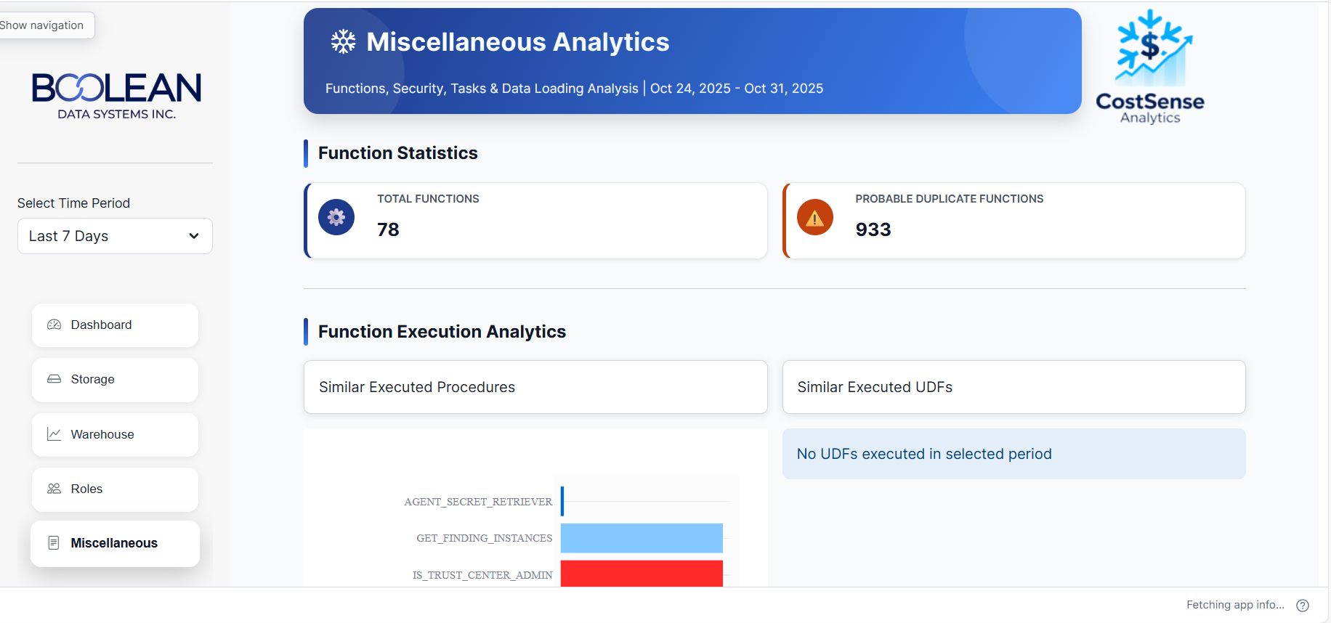
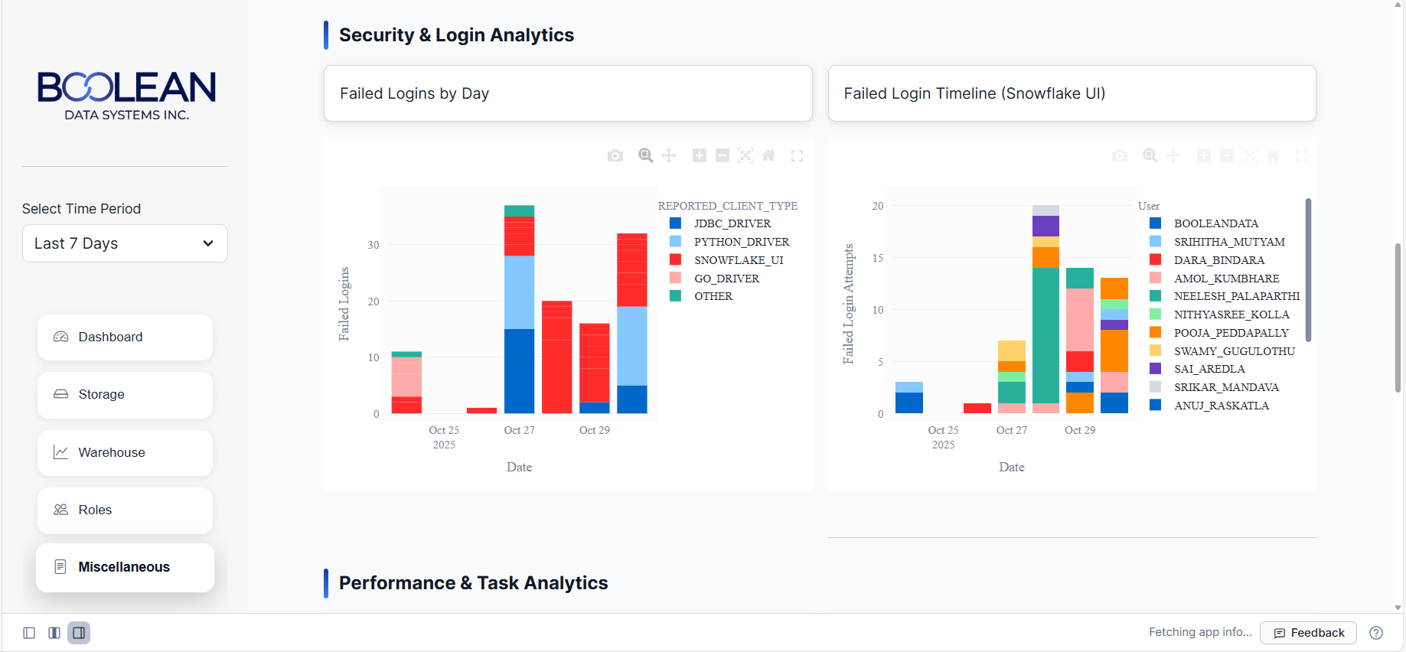
8. Data Design
Data Flow Architecture
The application operates as a read-only client-side interface to Snowflake's system views and metadata repositories. No application-specific database is required as all data is sourced directly from Snowflake's Account Usage and Information Schema views with minimal caching and transformation.
Key Data Sources
ACCOUNT_USAGE Schema:
- QUERY_HISTORY: Query execution metrics, performance, and resource usage
- WAREHOUSE_METERING_HISTORY: Credit consumption by warehouse
- DATABASE_STORAGE_USAGE_HISTORY: Storage metrics by database
- STAGE_STORAGE_USAGE_HISTORY: Stage-level storage details
- LOGIN_HISTORY: User login events (successful and failed)
- TASK_HISTORY: Scheduled task execution records
- USERS: User account information and status
- ROLES: Role definitions and properties
- GRANTS_TO_USERS: User privilege assignments
- GRANTS_TO_ROLES: Role privilege inheritance
INFORMATION_SCHEMA:
- TABLES: Table metadata and structure
- SCHEMATA: Schema information
- DATABASES: Database objects and properties
- VIEWS: View definitions
System Metadata (SHOW Commands):
- SHOW WAREHOUSES: Current warehouse configuration
- SHOW USERS: Active user listing
- SHOW ROLES: Available roles
- SHOW RESOURCE MONITORS: Credit limit configurations
Caching Strategy
- Metadata Caching: 90 seconds TTL for INFORMATION_SCHEMA queries
- Usage Data Caching: 300-1800 seconds TTL based on data volume (larger datasets cache longer)
- Chart Data Caching: 600 seconds for aggregated chart data
- Environment-specific Keys: Separate cache entries per date range and filter combination
- Cache Invalidation: Automatic on timeout or manual via refresh button
- Selective Caching: Critical path queries cached, one-time queries not cached
Data Aggregation Strategy
- Database Level: All aggregations performed in SQL (GROUP BY, SUM, AVG, MAX)
- Minimal Transfer: Only required columns selected (no SELECT *)
- Date Partitioning: Queries filtered by date range before return
- Result Limiting: Top-N queries limited at source (LIMIT clause)
- Pagination: Large result sets paginated client-side.
9. Technology Stack
Core Technologies
Frontend Framework: Streamlit 1.28+ for rapid web application development
Visualization Library: Plotly Express and Graph Objects for interactive charts
Database Connectivity: Snowflake Python Connector and Snowpark
Data Processing: Pandas for data manipulation and analysis
Numeric Processing: NumPy for array operations and calculations
Authentication: Snowflake native authentication with role-based access
Styling: Custom CSS with corporate design system implementation
UI Components: streamlit-option-menu for navigation
Date/Time: Python datetime and pytz for timezone-aware operations
Graphing: Graphviz for graph visualization (if applicable)
Development Tools
- Version Control: Git with feature branching strategy
- Testing: Pytest for unit testing with fixtures
- Code Quality: Black for formatting, Pylint for linting
- Pre-commit Hooks: Automated code quality checks
- Documentation: Sphinx for API docs, Markdown for user guides
- IDE: Visual Studio Code or PyCharm recommended
10. Security & Privacy
Authentication & Authorization
- Snowflake Authentication: Native Snowflake user authentication (username/password or SSO)
- Role-Based Access: Application access controlled by Snowflake roles
- Session Management: Secure session handling with automatic timeout
- Credentials Storage: Encrypted secrets in .streamlit/secrets.toml
- Account Isolation: Session state prevents cross-user data leakage
Data Security
- Connection Encryption: TLS 1.2+ for all Snowflake connections
- Read-Only Operations: Application uses SELECT-only queries on system views
- Credential Management: Secrets not logged or exposed in error messages
- SQL Injection Prevention: Parameterized queries for all user input (date filters)
- Data Minimization: Only necessary columns selected from ACCOUNT_USAGE views
Privacy Controls
- Data Minimization: Only system metadata accessed, no business data processed
- Audit Trail: All queries logged in Snowflake QUERY_HISTORY
- Access Logging: User identity tracked through Snowflake session
- Data Retention: System views cleaned up per Snowflake retention policies
- Right to Deletion: Data automatically deleted per Snowflake lifecycle
Compliance Features
- Audit Trail: Complete audit via ACCOUNT_USAGE views
- Role Separation: Read-only access to all operations
- Least Privilege: IMPORTED PRIVILEGES required on system database
- Regular Access Review: Tools for monitoring access patterns
- Snowflake-Native Compliance: Inherits compliance certifications of Snowflake
11. Best Practices for Users
Cost Optimization
- Monitor warehouses consuming >15% of total credits for optimization opportunities
- Review database storage monthly for unused objects
- Set warehouse auto-suspend to 5 minutes or less
- Identify and optimize queries with remote storage spillage
- Archive unused databases to separate stages
Performance Monitoring
- Review long-running queries (>10 minutes) weekly
- Monitor failed task execution trends (target: <1% failure rate)
- Track query spillage patterns for optimization priorities
- Monitor role-based query patterns for resource allocation insights
- Use trend analysis to forecast consumption
Security & Compliance
- Review role assignments monthly
- Remove users immediately upon termination
- Monitor failed login attempts for security incidents
- Audit elevated privilege assignments quarterly
- Document all privilege changes for compliance
Operational Practices
- Use consistent naming conventions for objects (ENV_TYPE_PURPOSE)
- Regularly refresh dashboard data via button
- Export cost reports monthly for stakeholder review
- Schedule optimization reviews (weekly minimum)
- Maintain audit trail for all administrative decisions
12. Performance Optimization
Query Optimization Strategies - SQL
-- Use date partitioning to filter early
WHERE START_TIME >= '{start_date}' AND START_TIME <= '{end_date}'
-- Aggregate at database level
GROUP BY WAREHOUSE_NAME, DATE(START_TIME)
-- Select only required columns
SELECT warehouse_name, SUM(credits_used) AS credits
-- Use approximate functions for sampling
SELECT APPROX_COUNT(DISTINCT USER_NAME)
Application Optimization
- Lazy loading: Only load active tabs
- Result pagination: Limit initial display
- Incremental updates: Update metrics asynchronously
- Connection pooling: Reuse Snowflake connections
13.Deployment Overview
The Costsense Accelerator deployment spans 7 phases within 12-24 hours total. Each phase builds upon the previous, ensuring a secure, tested, production-ready implementation.

Phase 1: Prerequisites
Snowflake Account Preparation
- Confirm ACCOUNTADMIN privileges for deployment administrator
- Create Costsense service account with strong password
- Create Costsense role with minimal necessary privileges
- Grant imported privileges on snowflake database for ACCOUNT_USAGE access
- Verify access to WAREHOUSES, QUERY_HISTORY, DATABASE_STORAGE_USAGE_HISTORY views
Infrastructure Preparation
- Cloud Deployment: Prepare GitHub repo and Streamlit Cloud account with pre-configured secrets
- Self-Hosted: Verify Linux server (Ubuntu 20.04+), Python 3.8+, 10GB disk, 4GB RAM, HTTPS connectivity
- Network: Configure firewall for port 443, DNS records, SSL/TLS certificates
Development Setup
- Clone application source code repository
- Create isolated Python virtual environment
- Prepare development workspace

Phase 2: Installation & Configuration
Dependencies
- Install all Python packages from requirements.txt (Streamlit, Pandas, Plotly, Snowflake connectors)
- Verify successful installation of each critical package
Configuration
- Create Streamlit config with corporate color scheme and settings
- Development: Snowflake connection details (account, user, password, warehouse, database, schema, role)
- Cloud: Configure secrets through Streamlit Cloud UI
- Production: Create environment file with restricted permissions
Assets
- Prepare 120x120px PNG logo files (<100KB)
- Create assets directory and copy logos
- Verify application correctly references asset files

Phase 3: Testing & Validation
Local Testing
- Start Streamlit development server and verify startup messages
- Verify Snowflake connection.

